Day-02
Commands for git
To initialize new git repository use git init
To clone git clone URL
To check status git status
To view commit history git log
Compact commit history git log --oneline

Task-01
What is the default permission for a newly created file and a directory?
Default permission for a new file: 644 (rw-r--r--)
• Default permission for a new directory: 755 (rwxr-xr-x)

Task 2:

Create a user using linux
11.45 to 11.48
Useradd Prasunamba
Or
Sudo adduser Prasunamba
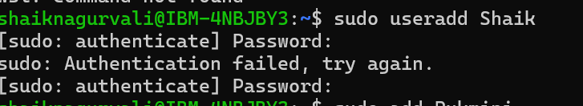

Task 3:
Delete the above user

Task 4:
Create another user
Change the password
Create a third user and switch to 2nd user
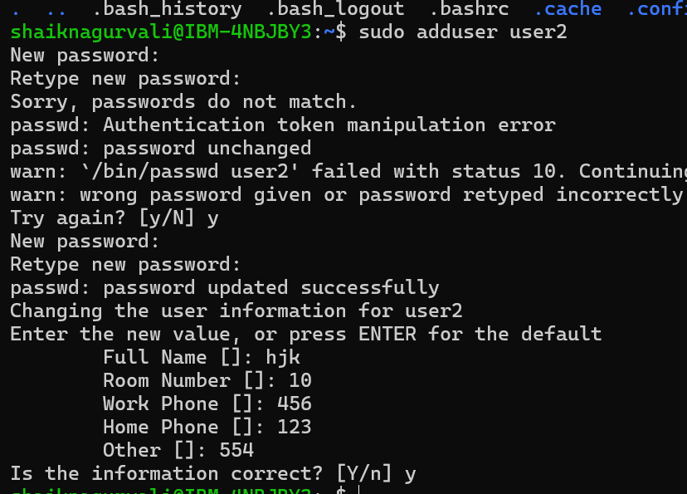

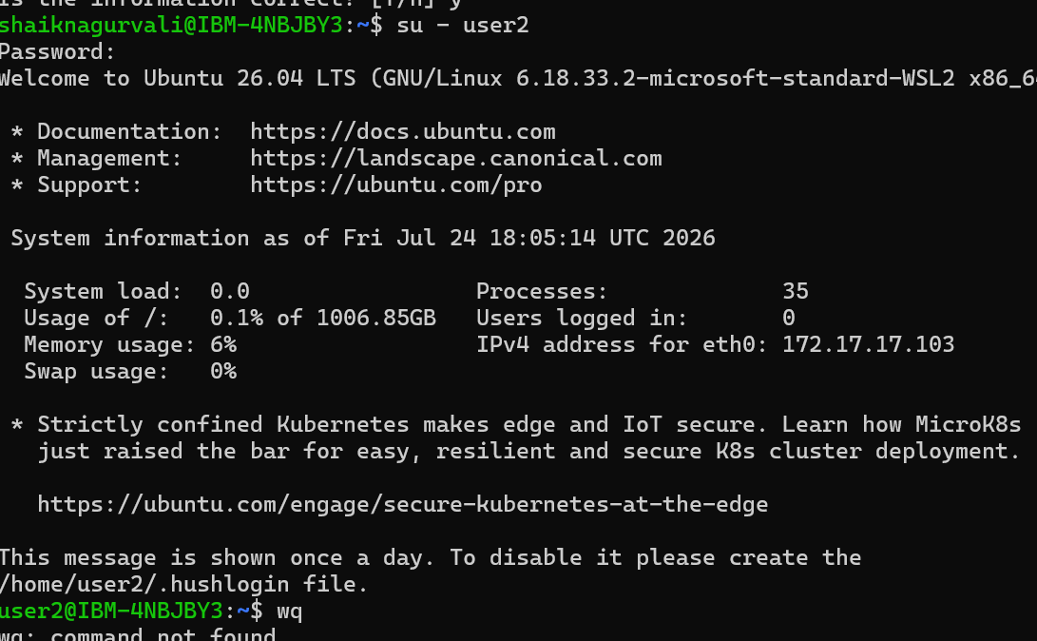

Task 5:
Find your system’s current time.
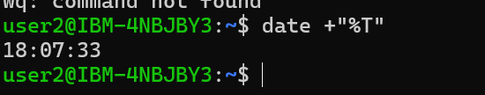

Task 6: What is the chown Command Used For?
chown stands for Change Owner. It is used to change the owner and/or group ownership of a file or directory.
Syntax
chown owner filename
Example:
sudo chown user2 sample.txt

Task 7: What is grep Used For?
grep is used to search for a specific word or pattern inside a file or command output.
Syntax
grep "word" filename
Example:
grep "Linux" notes.txt

Task 8: How to Use Redirecting in Linux?
Redirection sends command output to a file instead of the terminal.
Overwrite output
echo "Hello" > file.txt
Append output
echo "Welcome" >> file.txt

Task 9: Open Any File Using vi

Task 10: Use hostname Command
Display the hostname:
Hostname
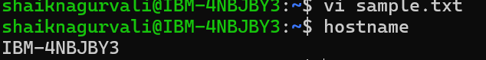

Task 11: Display Detailed System Information
uname -a
Task 12: Use sudo Command
Example:
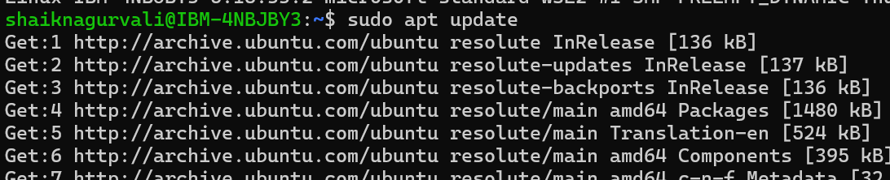

Command | Description | Example
pwd | Print current working directory | pwd
ls | List files and directories | ls -l
cd | Change directory | cd /home/user
mkdir | Create a directory | mkdir project
rmdir | Remove an empty directory | rmdir folder
rm | Remove files/directories | rm file.txt, rm -r folder
cp | Copy files/directories | cp file1 file2
mv | Move or rename files | mv old.txt new.txt
touch | Create an empty file
Task-13
Http and Https
Http-It is a protocol to transfer the data from web browser to web server, and data will be sent in the plain text, and it is not secure
Https-It is a protocol which is very secure and it is encrypted version of http and data security will be there
Ex: payment gateway and card details etc...

Task-14
Methods Http protocol
Get
Post
Put
Patch
Delete

Task-15
Status codes of Http
400 Bad Request
401 Unauthorized
403 Forbidden
404 Not Found R
405 Method Not Allowed
408 Request Timeout
409 Conflict

Task 16: What Do You Understand by HTTP Headers?
HTTP headers are key-value pairs exchanged between a client and a server. They carry additional information about the request or response, such as content type, authentication, caching, and browser details.

